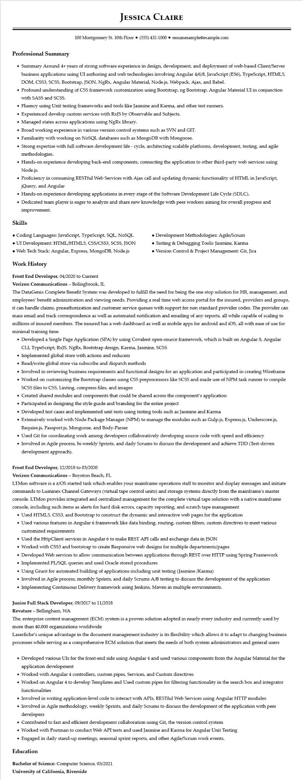
Professional Summary
JESSICA CLAIRE
100 Montgomery St. 10th Floor (555) 432-1000⚫ resumesample@example.com
• Summary Around 4+ years of strong software experience in design, development, and deployment of web-based Client/Server business applications using UI authoring and web technologies involving Angular 4/6/8, JavaScript (ES6), TypeScript, HTML5, DOM, CSS3, SCSS, Bootstrap, JSON, NgRx, Angular Material, Node.js, Webpack, Ajax, and Babel.
• Profound understanding of CSS framework customization using Bootstrap, ng Bootstrap, Angular Material UI in conjunction with SASS and SCSS.
• Fluency using Unit testing frameworks and tools like Jasmine and Karma, and other test runners.
• Experienced develop custom services with RxJS by Observable and Subjects.
• Managed states across applications using NgRx library.
• Broad working experience in various version control systems such as SVN and GIT.
• Familiarity with working on NoSQL databases such as MongoDB with Mongoose.
• Strong expertise with full software development life-cycle, architecting scalable platforms, development, testing, and agile methodologies.
• Hands-on experience developing back-end components, connecting the application to other third-party web services using Node.js.
• Proficiency in consuming RESTful Web Services with Ajax call and updating dynamic functionality of HTML in JavaScript, jQuery, and Angular
• Hands-on experience developing applications in every stage of the Software Development Life Cycle (SDLC).
• Dedicated team player is eager to analyze and share new knowledge with peer workers aiming for overall progress and improvement.
Skills
• Coding Languages: JavaScript, TypeScript, SQL, NOSQL
• UI Development: HTML/HTML5, CSS/CSS3, SCSS, JSON
• Web Tech Stack: Angular, Express, MongoDB, Node.js
Work History
Front End Developer, 04/2020 to Current
Verizon Communications - Bolingbrook, IL
• Development Methodologies: Agile/Scrum
• Testing & Debugging Tools: Jasmine, Karma • Version Control & Project Management: Git, Jira
The DataGenix Complete Benefit System was developed to fulfill the need for being the one stop solution for HR, management, and employees' benefit administration and viewing needs. Providing a real time web access portal for the insured, providers and groups, it can handle claims, preauthorization and customer service queues with support for non standard provider codes. The provider can mass email and track correspondence as well as automated notification and emailing of any reports, all while capable of scaling to millions of insured members. The insured has a web dashboard as well as mobile apps for android and iOS, all with ease of use for minimal training time.
• Developed a Single Page Application (SPA) by using Covalent open-source framework, which is built on Angular 8, Angular CLI, TypeScript, RxJS, NgRx, Bootstrap design, Karma, Jasmine, SCSS
• Implemented global store with actions and reducers
• Read/write global store via subscribe and dispatch methods
• Involved in reviewing business requirements and functional designs for an application and participated in creating Wireframe
• Worked on customizing the Bootstrap classes using CSS preprocessors like SCSS and made use of NPM task runner to compile SCSS files to CSS, Linting, compress files, and images
• Created shared modules and components that could be shared across the component's application
• Participated in designing the style guide and branding for the entire project
• Developed test cases and implemented unit tests using testing tools such as Jasmine and Karma
• Extensively worked with Node Package Manager (NPM) to manage the modules such as Gulp.js, Express.js, Underscore.js, Require.js, Passport.js, Mongoose, and Body-Parser
• Used Git for coordinating work among developers collaboratively developing source code with speed and efficiency
• Involved in Agile process, bi-weekly Sprints, and daily Scrums to discuss the development and achieve TDD (Test-driven development approach).
Front End Developer, 12/2018 to 03/2020
Verizon Communications - Boynton Beach, FL
LTMon software is a z/OS started task which enables your mainframe operations staff to monitor and display messages and initiate commands to Luminex Channel Gateways (virtual tape control units) and storage systems directly from the mainframe's master console. LTMon provides integrated and centralized management for the complete virtual tape solution with a native mainframe console, including such items as alerts for hard disk errors, capacity reporting, and scratch tape management
• Used HTML5, CSS3, and Bootstrap to construct the dynamic and interactive web pages for the application
• Used various features in Angular 6 framework like data binding, routing, custom filters, custom directives to meet various customized requirements
• Used the HttpClient services in Angular 6 to make REST API calls and exchange data in JSON
• Worked with CSS3 and bootstrap to create Responsive web designs for multiple departments/pages
• Developed Web services to allow communication between applications through REST over HTTP using Spring Framework
• Implemented PL/SQL queries and used Oracle stored procedures
• Using Grunt for automated building of applications including unit testing (Jasmine /Karma)
• Involved in Agile process, monthly Sprints, and daily Scrums A/B testing to discuss the development of the application
• Implementing Continuous Delivery framework using Jenkins, Maven in multiple environments.
Junior Full Stack Developer, 09/2017 to 11/2018
Revature - Bellingham, WA
The, enterprise content management (ECM) system is a proven solution adopted in nearly every industry and currently used by more than 40,000 organizations worldwide
Laserfiche's unique advantage in the document management industry is its flexibility which allows it to adapt to changing business processes while serving as a comprehensive ECM solution that meets the needs of both system administrators and general users
• Developed various UIs for the front-end side using Angular 4 and used various components from the Angular Material for the application development
• Worked with Angular 4 controllers, custom pipes, Services, and Custom directives
• Worked on Angular 4 to develop Templates and Used custom pipes for filtering functionality in the search box and integrator functionalities
• Involved in writing application-level code to interact with APIs, RESTful Web Services using Angular HTTP modules
• Involved in Agile methodology, weekly Sprints, and daily Scrums to discuss the development of the application with peer developers
• Contributed to fast and efficient development collaboration using Git, the version control system
• Worked with Postman to conduct Web API tests and used Jasmine and Karma for Angular Unit Testing
• Engaged in daily stand-up meetings, seasonal sprint reports, and other Agile/Scrum work events.
Education
Bachelor of Science: Computer Science, 03/2021
University of California, Riverside

